<http://www.thehindubusinessline.com/markets/commodities/karnataka-wants-centre-to-buy-more-tur-for-buffer-stocks-extend-purchase-period/article9610534.ece>

**BENGALURU MARCH 31:**

Prices of tur (red gram) continue to rule below the minimum support price (MSP) levels in Karnataka, though procurement of the pulses crop is seen registering a 10-fold increase in the current year over the previous high.

As a result, the State is approaching the Centre to increase procurement by another 1.5 lakh tonnes while extending the purchase period by a month.

“The procurement we have done this year is mind-blowing,” said Karnataka Agriculture Minister Krishna Byre Gowda.

“We have crossed 2 lakh tonnes till March 28 and expect the procurement to exceed 2.4 lakh tonnes by April 8, which is about 10 times higher than the previous high. We are approaching the Centre to procure an additional 1.5 lakh tonnes for the buffer stocks and extend the procurement deadline by a month.”

The previous highest procurement of tur in Karnataka was 25,000 tonnes in 2013-14. Production of pulses in the State, including tur, has risen by a third to 14 lakh tonnes in 2016-17 on higher acreages.

Meanwhile, the Centre has procured 1.68 million tonnes of pulses as of Tuesday, out of the targeted 2 million tonnes for its buffer stock, CR Chaudhary, Minister of State for Food, said in a written reply in the Rajya Sabha on Friday.

Of the total pulses procured, 3.79 lakh tonnes were from imports.

Despite an increase in procurement, prices continue to rule below the MSP of ₹5,050 per quintal across many markets in Karnataka on higher arrivals. “Prices are still ruling at ₹3,500-4,500 per quintal in various markets,” said Basavaraj Ingin, President of the Karnataka Tur Growers Association in Gulbarga, the major producing region.

Though the Centre has recently imposed a 10 per cent duty on imports to arrest the price fall, growers feel the quantum of duty is insufficient to have any impact, mainly on account of a bumper output.

“We are urging the Centre to impose a duty of minimum 25-30 per cent on tur imports,” Ingin said.

Tur production in the country is estimated at 4.23 million tonnes for the 2016-17 season, almost double the 2.56 million produced last year.

Higher prevailing prices of pulses during the planting season in 2016 kharif had prompted farmers to switch acreages in favour of pulses, resulting in a bumper output.

The article reports that India has a minimum price support on tur to prevent shortage. However, the price in the market continues to fall and the government is trying to resolve it by having more procurement.

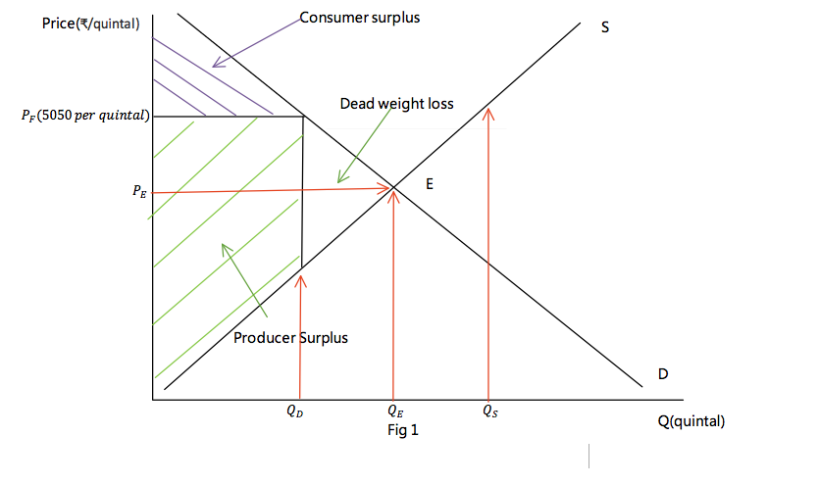 The main measure government took to control the price of tur is setting up a minimum price support as mentioned in the article. A minimum price support (MPS) is a price floor which is the legal minimum price of a good. India set its MPS to be ₹5,050 per quintal, which prevents the price of tur to go lower than that price. Tur is a staple good since it is consumed by a lot of people in south Asia, and with the price floor, shortage of tur will less likely to happen and the producers of tur will be protected.

However, a lot of unintended consequences come with the use of price floor. As shown in figure one, when a price floor was set at $P_{F}$, the quantity demand drops from Qe to Qd, and the quantity supply rises from Qe to Qs which leads to a surplus of tur which decrease the equilibrium price of tur. A surplus means that the marginal cost is bigger than marginal benefit within the market which prevent allocative efficiency from being achieved. The decrease in the quantity demanded shows a reduction in the number of exchange which reduce the market size. With less demand and higher prices, a dead weight loss was created. In addition, tur is a staple goods so poor people can’t afford it with the price floor, so they will create informal markets that sell tur at cheaper prices and these informal markets can be hard to destroy. Because there is a price floor, more suppliers will supply tur in the market which decreases the price of tur and eliminate the effect of price floor.

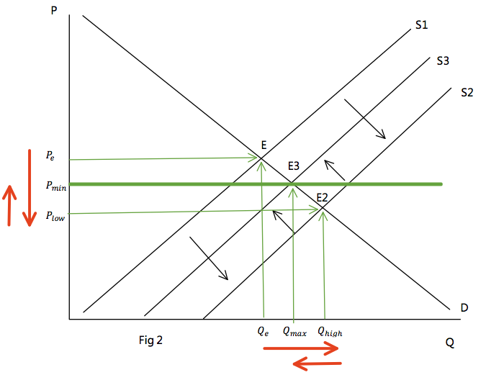 As mentioned in the article, the price of tur drops below the MPS which is highly likely that it is resulted from the price floor. To stop the price from further decreasing, India government decide to increase the procurement. Procurement, which is also known as buffer stock, is a measure government took to control the price of a good. When there is a shortage, government will release some goods to decrease the price of the good; When there is a surplus, government will buy more goods to increase the price of the good, which, protect the suppliers. As shown in figure 2, when the supply curve shifts to S2 and increase the quantity supplied, the government would store some goods and shifts supply to S3, the quantity supplied in the market was decreased and the price increases from Plow to Pmin.

The India government should keep the MPS and keep increasing the procurement because all the unintended consequences of MPS can be resolved through other measures but the shortages created by not having the price support is hard to resolve.

Without price floor, in short run, a lot more consumers would be able to purchase tur. However, in long run, shortages might appear which prevents a lot of consumers from buying the goods. Therefore, keeping the price floor would be a better solution since it benefits the consumers in the long run and it protects the producers. Many poor consumers might not be able to purchase tur due to the floor, the government can give subsidy to poor consumers that cannot afford the price which enables more people to be able to buy tur. Without buffer stock, in short run, government can save money and the consumers can afford tur at a lower price due to surplus, but in long run, surplus appeared from price floor might affect some producers and many of them will quit which might lead to shortage which affect the consumers in long run. On the other hand, if there is a buffer stock, producers will be benefited since the price of tur won't go down too much and the consumers would be benefited since there is less likely to be shortage. The government can also use the procurement to resolve shortage brought by supply in the long run which benefits consumers. Therefore, the buffer stock should be kept and can increase if possible. Government will be affected since they must spend more money on procurements. This spending can be decreased through exporting the tur to other countries which gives the government some revenue while reducing the amount needed to buy for buffer stocks.